SAP Integration Suite
Cloud Integration

Technical Specification Document

Foundation_BusinessDocumentPDF_Bravo_Subscriber

Version: 1.0
Author: Generated by AI
Date: May 01, 2026
Status: Draft

Table of Contents
1. Change History
1.1 Document Control
2. Overview
2.1 Executive Summary
2.2 Purpose
2.3 Interface Requirement
2.4 Functional Assumptions
2.5 Integration Snapshot
3. High level iFlow Design
3.1 Current Scenario
3.2 To-Be Scenario
3.3 High Level Design
3.4 Technical Dependencies
4. Message Flow
4.1 Process Flow
4.2 Message Flow Connections
4.3 Integration Flow Diagram
5. Technical Description
5.1 Main Integration Process
5.2 Local Integration Process
5.3 Sender
5.4 Receiver
5.5 Mappings
5.6 Security
5.7 Groovy Scripts
5.8 Error Handling & Logging
6. Version and Metadata
7. Appendix
7.1 Technical Artifacts
7.2 Schemas
7.3 Externalized Parameters

1. Change History
Version | Date | Author | Description
1.0 | 2026-05-01 | Generated by AI | Initial autogenerated version

1.1 Document Control
- Document ID: TS-Foundation_BusinessDocumentPDF_Bravo_Subscriber
- Integration Flow: Foundation_BusinessDocumentPDF_Bravo_Subscriber
- Generated On: 2026-05-01 00:52
- Generation Mode: Batch
- Diagrams Included: Yes
- Functional Spec Context: Not Provided

2. Overview

2.1 Executive Summary
The iFlow Foundation_BusinessDocumentPDF_Bravo_Subscriber receives a business document, extracts the Base64 encoded PDF content, and uploads it to an AWS S3 bucket. It also logs technical exceptions to a JDBC database. This integration automates the process of archiving business documents in PDF format to AWS S3.

2.2 Purpose
This document provides a technical specification for the Foundation_BusinessDocumentPDF_Bravo_Subscriber iFlow, outlining its functionality, configuration, and dependencies.

2.3 Interface Requirement
The business requirement is to automatically archive business documents in PDF format to AWS S3 for long-term storage and retrieval.

2.4 Functional Assumptions
Assumption | Value
Frequency | Real-time
Volume | Not configured
Processing Type | Async, XML
Performance | Not configured

2.5 Integration Snapshot
Metric | Value
Integration Processes | 2
Message Flows | 3
Sequence Flows | 14
Groovy Scripts | 1
Schemas | 2
Externalized Parameters | 4

3. High level iFlow Design

3.1 Current Scenario
No automated integration

3.2 To-Be Scenario
The integration enables the automated transfer of business document PDFs from the Foundation system to an AWS S3 bucket, along with logging of technical exceptions in a SynLogisticsPlatform database.

3.3 High Level Design
The iFlow uses an HTTPS sender adapter to receive the business document from the Foundation system. It then extracts the PDF content and uses an Amazon Web Services S3 receiver adapter to upload the PDF to the specified S3 bucket. A JDBC receiver adapter is used to log technical exceptions to a database.

3.4 Technical Dependencies
- Runtime platform: SAP CI integration flow 'Foundation_BusinessDocumentPDF_Bravo_Subscriber' orchestrates message exchange from Foundation to AWS-S3.
- Inbound interface dependency: path /businessDocument/IDT; HTTPS adapter using None over HTTPS; sender auth type RoleBased with role ESBMessaging.send.
- Outbound interface dependency: URL amazonaws.com; receiver authentication type Not configured with credential/security artifact LogisticsPlatform; operation write.
- Security dependency: sender auth type RoleBased with user role ESBMessaging.send; receiver authentication type Not configured with credential/security artifact LogisticsPlatform.
- Design-time artifacts: mappings src\main\resources\mapping\BusinessDocumentMapping.mmap.
- Custom script artifacts: concatenate.groovy.
- Externalized runtime dependencies: 4 parameter(s) supplied.

4. Message Flow
A message comes from Foundation into SAP CI through the configured sender channel.
SAP CI processes the payload and sends the final message to AWS-S3 through the receiver channel.

4.1 Process Flow
Step | Description
1 | Step 1: Foundation system sends a business document via HTTPS to the Integration Suite.
2 | Step 2: Integration Suite receives the document and extracts the Base64 encoded PDF content, filename, and folder name.
3 | Step 3: The PDF is uploaded to the specified AWS S3 bucket and folder.
4 | Step 4: A database table is updated with document metadata, and technical exceptions are logged via JDBC.

Flow Attribute | Value
Target System | AWS-S3
Trigger | Event

4.2 Message Flow Connections
Connection | Name
call to S3 -> AWS-S3 | AmazonWebServices
Query JDBC -> SynLogisticsPlatform_Database | JDBC
Foundation -> Start | HTTPS

4.3 Integration Flow Diagram
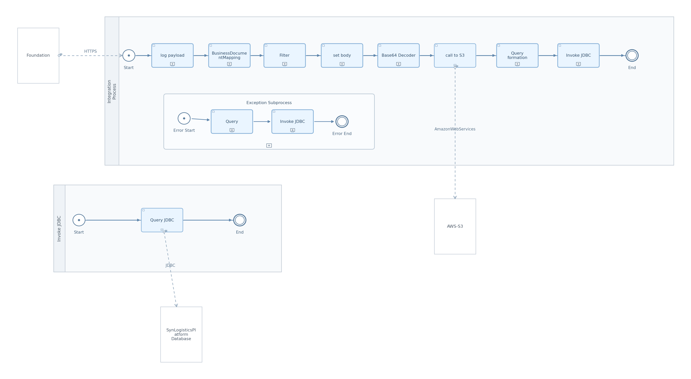
Figure: Integration Flow Diagram

5. Technical Description

5.1 Main Integration Process
Process Name | Sequence Flows | Flow Elements
Invoke JDBC | 2 | 3

Invoke JDBC
This process calls a JDBC receiver adapter to execute a database query.
Key Activity
ExternalCall

Step | Description
1 | Step 1: Start event.
2 | Step 2: Service task to query JDBC.
3 | Step 3: End event.

Key | Value
Transaction Timeout | 30
Process Type | directCall
Transactional Handling | From Calling Process

5.2 Local Integration Process
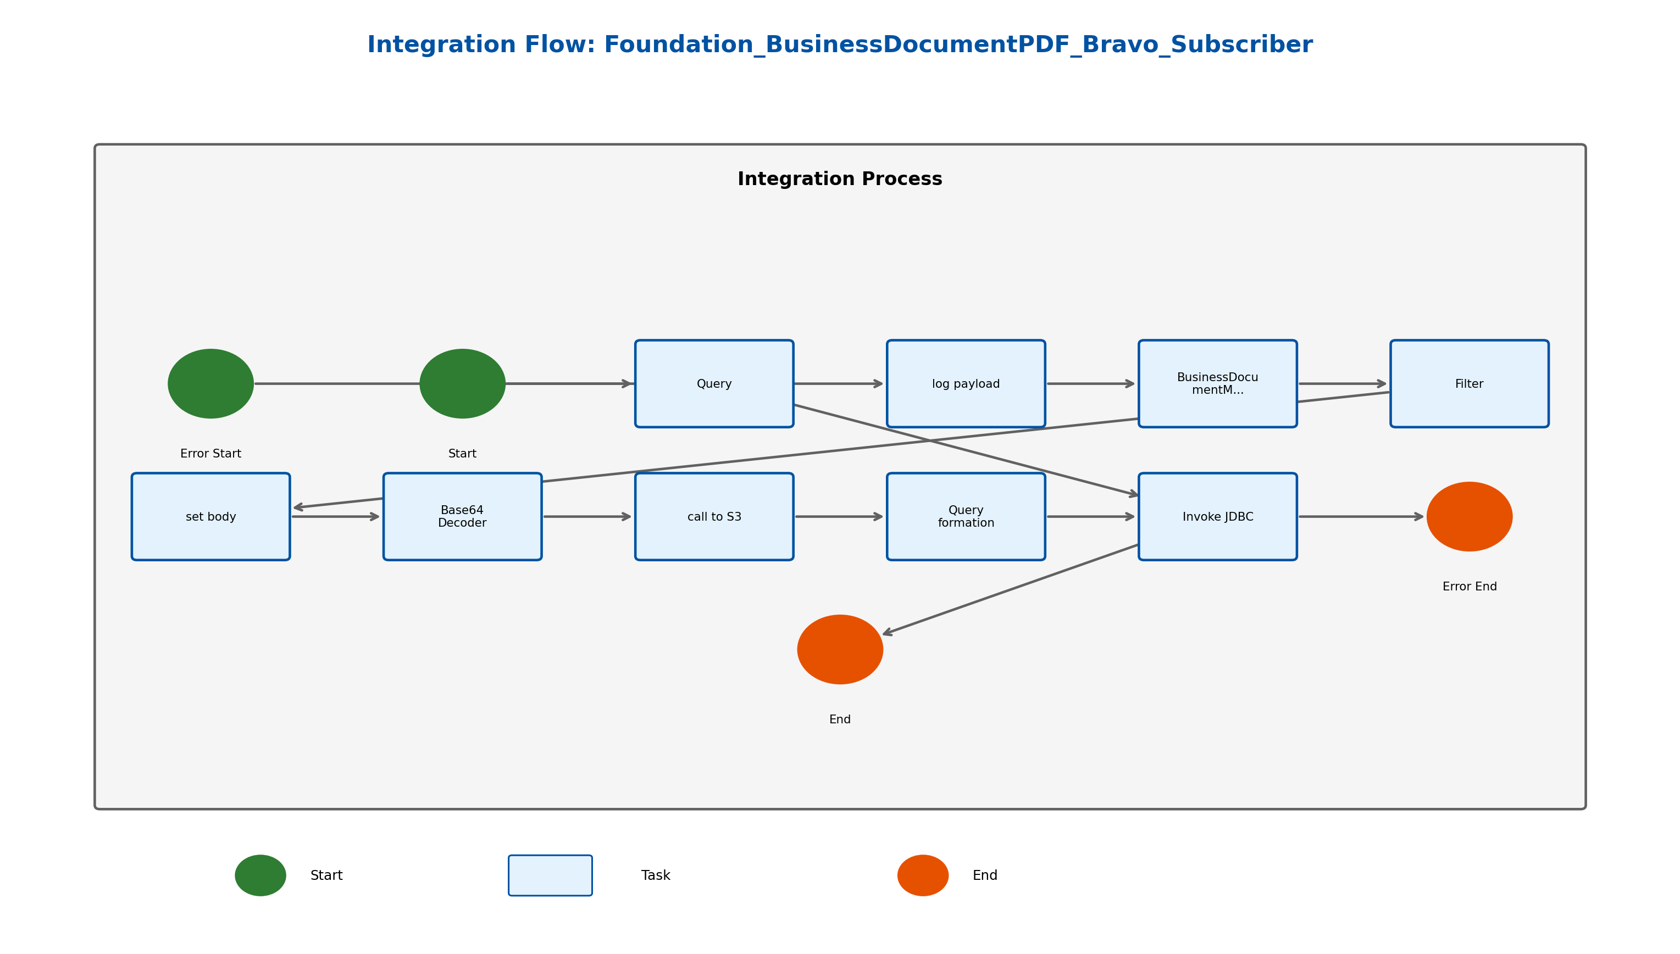
Figure: Integration Process Diagram

Process Name | Sequence Flows | Flow Elements
Integration Process | 12 | 11

Integration Process
This is the main integration process that orchestrates the flow of messages, data transformation, and calls to external systems.
Key Activity
Enricher
ExternalCall
SubProcess

Step | Description
1 | Step 1: Receive message from HTTPS sender.
2 | Step 2: Extract properties from payload.
3 | Step 3: Upload PDF to AWS S3.
4 | Step 4: Update database with document metadata.
5 | Step 5: Handle exceptions.

Key | Value
Transaction Timeout | 30
Transactional Handling | Not Required

callActivity Query formation Properties
Key | Value
Body Type | expression
Wrap Content | CALL sp_crud_dt_docfolder_and_documentlist('${property.FolderName}', '${property.IDENTIFIER}', NULL, NULL, NULL, NULL, '${property.FileName}.pdf', '1', '${property.DOC_NUMBER}', 'F');

callActivity set body Properties
Key | Value
Body Type | expression
Wrap Content | ${property.payload}

callActivity log payload Properties
Key | Value
Body Type | constant

callActivity Filter Properties
Key | Value
Body Type | constant

callActivity Invoke JDBC Properties
Key | Value
Process Id | Process_40623567
Sub Activity Type | NonLoopingProcess

callActivity Base64 Decoder Properties
Key | Value
Encoder Type | Base64 Decode

5.3 Sender
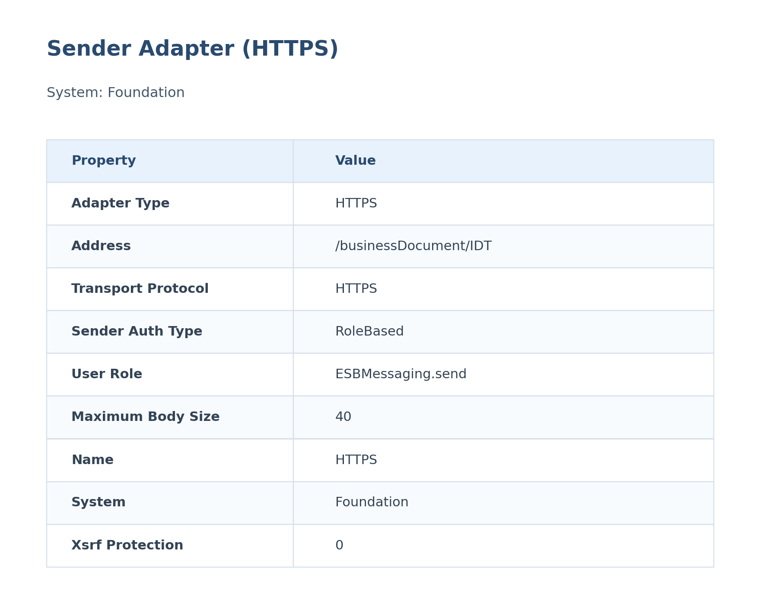
Figure: Sender Configuration

The HTTPS sender adapter receives the business document from the Foundation system. It is configured to use role-based authentication, requiring the ESBMessaging.send role. The maximum body size is set to 40 MB.
Attribute | Value
Path / Address | /businessDocument/IDT
Adapter Type | HTTPS
Protocol | HTTPS
Auth Type | RoleBased
User Role | ESBMessaging.send

5.4 Receiver
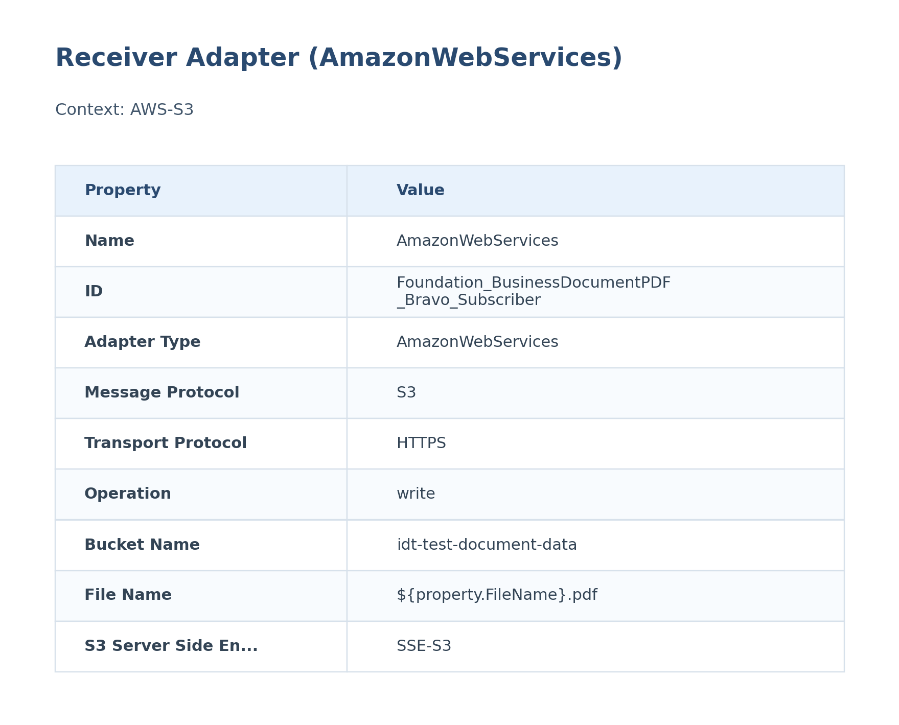
Figure: Receiver Configuration

The Amazon Web Services S3 receiver adapter uploads the PDF to the specified S3 bucket. It is configured to use HTTPS and access key/secret key authentication. Server-side encryption (SSE-S3) is enabled.
Attribute | Value
URL / Address | amazonaws.com
Adapter Type | AmazonWebServices
Authentication Type | Not configured
Credential / Security Artifact | LogisticsPlatform
Operation Name | write

5.5 Mappings

BusinessDocumentMapping
This mapping applies the configured transformation logic for BusinessDocumentMapping within SAP CI.
It is executed during message processing to reshape the payload before the next handoff.
Attribute | Value
Source Message / Object | BusinessDocumentMapping
Target Message / Object | Not identified
Mapping File | src\main\resources\mapping\BusinessDocumentMapping.mmap

5.6 Security
Security Aspect | Details
Authentication | RoleBased for HTTPS sender, AWS Access Key/Secret Key for S3, JDBC alias for database
Authorization | ESBMessaging.send role for sender
Encryption | HTTPS for sender, SSE-S3 for S3 receiver

Key | Value
Http Session Handling | None
Return Exception To Sender | false
Log | All events
Cors Enabled | false
Server Trace | false
Access Control Allow Credentials | false

5.7 Groovy Scripts
Groovy scripts are used within the mapping to perform custom data transformations. The concatenate.groovy script is used to concatenate strings.

concatenate.groovy
This script concatenates multiple input strings into a single string.
[Groovy]
import com.sap.it.api.mapping.*;
/*Add MappingContext parameter to read or set headers and properties
def String customFunc1(String P1,String P2,MappingContext context) {
String value1 = context.getHeader(P1);
String value2 = context.getProperty(P2);
return value1+value2;
}
Add Output parameter to assign the output value.
def void custFunc2(String[] is,String[] ps, Output output, MappingContext context) {
String value1 = context.getHeader(is[0]);
String value2 = context.getProperty(ps[0]);
output.addValue(value1);
output.addValue(value2);
}*/
def void concatenate(String[] is, Output output, MappingContext context) {
String str="";
for(int i=0;i<is.length;i++){
str=str+is[i];
}
output.addValue(str);
}

5.8 Error Handling & Logging
Aspect | Details
Description | The iFlow includes an exception subprocess to handle errors. When an error occurs, the exception subprocess logs the error details to the SynLogisticsPlatform database.
Exception Handling | The exception subprocess calls a stored procedure to log the exception details, including the document number, folder name, and error message.
Alerting | Not configured
Retry Logic | Not configured

Exception SubProcess Diagram
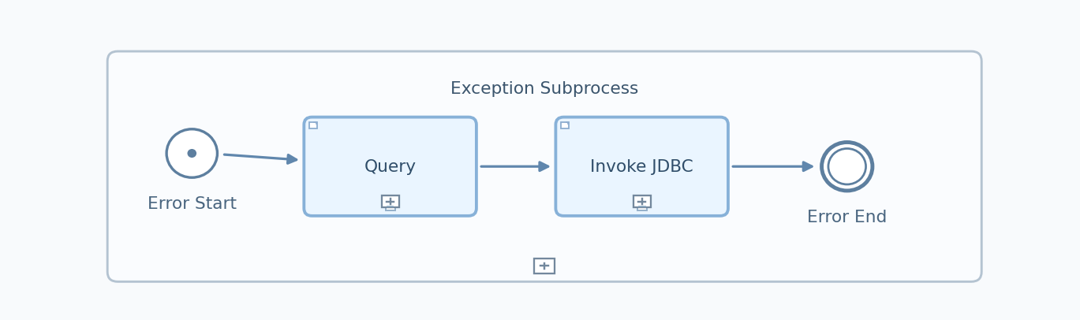
Figure: Exception SubProcess (Copied from Integration Flow Diagram)

Exception SubProcess 1 Properties

Child Element: callActivity Query
Key | Value
bodyType | expression
wrapContent | call public.sp_crud_bravo_order_technical_exception_log( 'F${property.DOC_NUMBER}','${property.FolderName}','FSAP', '', 'Foundation_BusinessDocumentPDF_Bravo_Subscriber','${exception.message}','${property.DOC_CREATION_DATE}', '${property.ExceptionSubProcessTimeStamp}');

Child Element: callActivity Invoke JDBC
Key | Value
processId | Process_40623567
subActivityType | NonLoopingProcess

6. Version and Metadata
Key | Value
Componentversion | 1.0
Version | 1.2
Package | Foundation_BusinessDocumentPDF_IDT_Subscriber
Author | Not found in iFlow
Description | This interface is created as subscriber flow for AWS S3 bravo pdf's. Daisy chained from PO interface FoundationERP_GTNexus_BusinessDocumentPDF_Glovia

7. Appendix

7.1 Technical Artifacts
- iFlow: Foundation_BusinessDocumentPDF_Bravo_Subscriber.iflw
- Groovy Script: concatenate.groovy
- Schema: BusinessDocument.xsd
- Schema: Delivery_Returns_PDF.xsd
- Message Flows: 3
- Sequence Flows: 14
- Mapping Activities: 1
- src/main/resources/script/concatenate.groovy
- src/main/resources/xsd/BusinessDocument.xsd
- src/main/resources/xsd/Delivery_Returns_PDF.xsd
- src/main/resources/mapping/BusinessDocumentMapping.mmap
- src/main/resources/scenarioflows/integrationflow/Foundation_BusinessDocumentPDF_Bravo_Subscriber.iflw

7.2 Schemas
File | Namespace | Elements | Complex Types
BusinessDocument.xsd | urn:erp:o2c:s:global:business:document:100 | 8 | 5
Delivery_Returns_PDF.xsd |  | 5 | 2

7.3 Externalized Parameters
Parameter | Value | Used In
AccessKey | Access_Key_AWS_S3_Bravo | Receiver - Access Key
Bucket Name | idt-test-document-data | Receiver - Bucket Name
SecretKey | Secret_Key_AWS_S3_Bravo | Receiver - Secret Key
SynLogisticsPlatform_Database | LogisticsPlatform | Receiver - Alias

